New Dis-Eur**-**Czech Republic-Pavlov-Late Paleolithic-22,000 BP-Mammoth-Ceramic

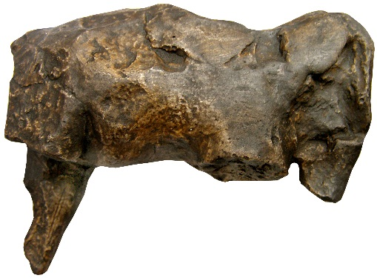 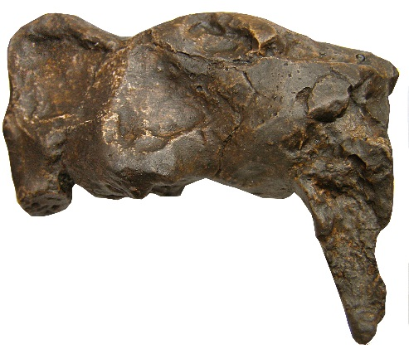

Figs. 1-2. Dis-Eur**-**Czech Republic-Pavlov-Late Paleolithic-22,000 BP-Mammoth-Ceramic

**Formal Label:** Dis-Eur**-**Czech Republic-Pavlov-Late Paleolithic-22,000 BP-Mammoth-Ceramic

**Display Description:**

**This is ceramic figurine of a mammoth which was made from clay from the banks of the** Dyje River in Moravia **as glaciers were advancing ca 22,000 BP during the LGM. Its lack of a hole for suspension as an amulet and its imperfect state of preservation suggests that it suffered from having been handled and therefore it may have been used to invoke sympathetic magic in the hopes of a successful hunt for mammoths as they followed the advancing glaciers.**

**Accession Number:**

**LC Classification:** DAW1023.I58

**Date or Time Horizon:** Late Paleolithic-22,000 BP

**Geographical Area:** Pavlov site 5-6, Czech Republic.

**Map and GPS Coordinates:**



Fig. 3. Pavlov sites 1-9 along the Dyje River in Moravia, After Jelinek 1990.

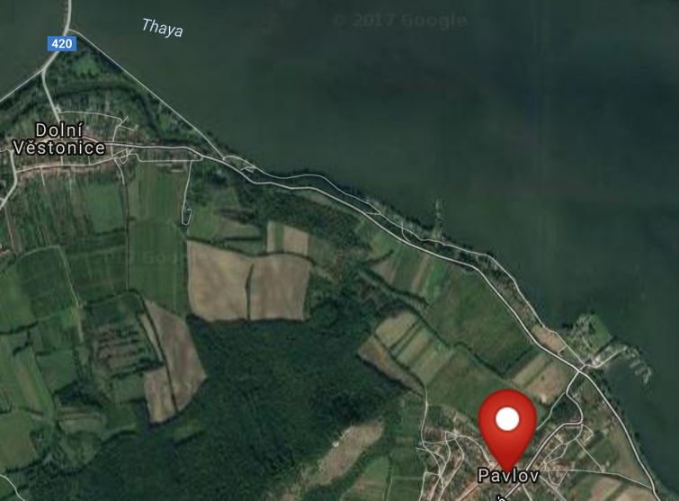 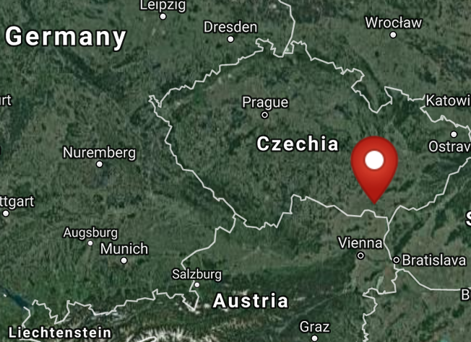

Figs. 4-5. Maps of Pavlov, Cech Republib from http://latitude.to/img/latitude-logo.svg



Fig. 6. Imaginative view of the villagers of Pavlov sites 5-6 in winter ca. 22,000 BP, painted by Giovanni Caselli. From http://www.donsmaps.com/images13/dolnivestonicelifeinwinter.jpg

**Cultural Affiliation:** Upper Paleolithic-22,000 BP-Pavlov Culture

**Medium:** original, ceramic.

**Dimensions:   
Weight:**

**Provenance: original, Archaeological Museum, Brno, Czech Republic.**

**Condition**: museum replica in resin.

**Discussion:**

Inhabitants of Pavlov VI site (Svoboda 2009) an Upper Paleolithic settlement and a satellite of Pavlov I, 200 m asl on the Dyje River in modelled baked clay figurines instead of using mammoth ivory. This ceramic figurine is a product of these Pavlov sites in the area.

**References:**

Jelinek, Jan. 1990. *Art in the Mirror of Ages: The Beginnings of Artistic Activities*. Brno: Moravian Museum.

Svoboda, Jirí, Miroslav Králík, Vera Culíková, Sárka Hladilová, Martin Novák, Miriam Nývltová Fisáková, Daniel Nývlt & Michaela Zelinková. 2009. Pavlov VI: an Upper Palaeolithic living unit, *Antiquity* 83 282-95.

Svoboda J. 2001. “Gravettian mammoth bone deposits in Moravia,” *The World of Elephants - International Congress.* Rome:International Congress. http://en.sovraintendenzaroma.it/content/download/4819/62548/file/359_362.pdf